Student Performance Prediction System

Project Id: AIML-5

Name : Harshita Joshi (Team Leader)
Class Roll Number: 06
University Roll Number :2028427
Section and Group: P G1

Name : Devesh Saini
Class Roll Number: 40
University Roll Number :2028706
Section and Group: P G1

Name : Anmol Gupta
Class Roll Number: 2028644
University Roll Number : 2028644
Section and Group: P G1

TABLE OF CONTENTS
- Problem Description 3
  - Dataset Description 3
  - Flow diagram 4
- Modules for Project Implementation…………………..…………………………5
  - Modules Used 5
  - Platform Used 6
- Machine Learning model/ Searching Technique used 7
- Evaluation metrics used 8
- Results and Visualizations 9
- Conclusion and Future Scope 11
- References 12

- Problem Description
- Air pollution is a critical environmental issue affecting human health and ecosystems. Monitoring and predicting air quality levels is essential for taking preventive actions and ensuring public safety. However, raw sensor data alone does not provide meaningful insights without proper analysis.
- This project aims to develop an Air Quality Level Classification System using Machine Learning. The system uses environmental sensor data such as CO (Carbon Monoxide), NO₂ (Nitrogen Dioxide), Temperature, Humidity, along with contextual information like city, disease conditions, and past medical records to classify air quality into categories such as Good, Moderate, and Poor.
- By incorporating both environmental and health-related parameters, the model can better understand how pollution affects individuals with different medical conditions. Data preprocessing techniques such as handling missing values, noise removal, categorical encoding, and feature scaling are applied. Feature selection helps retain important pollution indicators and remove less useful attributes.
- The classification is performed using K-Nearest Neighbors (KNN) , Logistic Regression algorithms , Decision Tree and Support Vector Machines(SVM). The models are evaluated using accuracy, precision, recall, and F1-score. This system can assist in environmental monitoring and provide health-aware air quality recommendations.

  - Dataset Description
Column names
- CO2
- NO2
- Temperature
- Humidity
- Air_Quality
- City
- Disease
- Past_medical_record

Number of rows= 2 Lakh

1.2 Flow Diagram

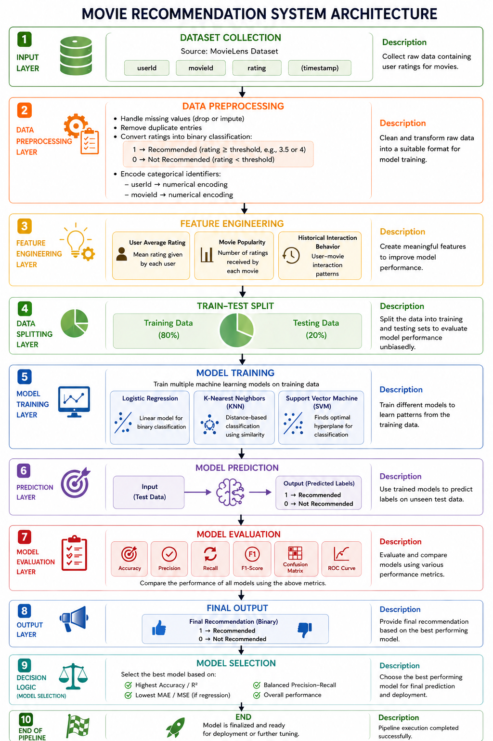

2. Modules for Project Implementation
1. NumPy
NumPy is a fundamental Python library used for numerical computing. It provides support for multi-dimensional arrays and mathematical operations.
Use in your program:
- Handling numerical data efficiently
- Performing array operations (e.g., conversions, calculations)
- Supporting underlying computations for ML models

2. Pandas
Pandas is a data manipulation library used for data analysis and preprocessing. It provides DataFrame and Series structures.
Use in your program:
- Loading dataset (CSV files)
- Handling missing values and duplicates
- Data transformation and feature engineering
- Filtering, grouping, and aggregating data

3. Matplotlib
Matplotlib is a plotting library used for creating basic visualizations.
Use in your program:
- Plotting graphs such as:
  - Line graphs
  - Histograms
  - Bar charts
- Visualizing trends and distributions in data

4. Seaborn
Seaborn is built on top of Matplotlib and provides advanced statistical visualizations with better aesthetics.
Use in your program:
- Plotting:
  - Heatmaps (especially confusion matrix)
  - Correlation matrix
  - Distribution plots
- Making graphs more visually appealing and informative

5. Scikit-learn (sklearn)
Scikit-learn is a machine learning library used for model building and evaluation.
Use in your program:
- Model training:
  - Logistic Regression
  - KNN
  - SVM
  - Decision Tree
- Data splitting (train_test_split)
- Evaluation metrics:
  - Accuracy, Precision, Recall, F1-score
- Preprocessing tools (scaling, encoding if used)

2.2 Platform Used: (mention all the platforms with the reason of using it)
  - Visual Studio Code: For code writing, testing, and debugging.
VS Code is equipped with multiple extensions, debugger which enhance the development experience.
  - Jupyter: for mainting an sharing the code in a compatible and trusted format

3. Machine Learning Model/ Searching Technique Used(Describe each ML model/ searching technique used)
1. Logistic Regression

Logistic Regression is a supervised machine learning algorithm used for binary classification problems. It models the probability that a given input belongs to a particular class using the logistic (sigmoid) function, which maps values between 0 and 1.
It is computationally efficient, interpretable, and works well when the relationship between features and output is approximately linear.

2. K-Nearest Neighbors (KNN)

KNN is a non-parametric, instance-based learning algorithm used for both classification and regression. It classifies a data point based on the majority class of its nearest neighbors in the feature space, typically using distance metrics like Euclidean distance.
KNN is simple to implement but can be computationally expensive for large datasets.

3. Support Vector Machine (SVM)

SVM is a powerful supervised learning algorithm used for classification and regression. It works by finding the optimal hyperplane that maximizes the margin between different classes.
SVM can handle both linear and non-linear data using kernel functions such as linear, polynomial, and radial basis function (RBF), making it highly effective in complex scenarios.

4. Decision Tree

Decision Tree is a tree-based supervised learning algorithm used for classification and regression. It splits the dataset into subsets based on feature conditions, forming a tree-like structure of decisions.
It is easy to interpret and visualize but may suffer from overfitting if not properly controlled.

4. Evaluation metrics used (Describe each evaluation metric used along with formulae)

1. Accuracy
Accuracy measures the overall correctness of the model.
$$Accuracy=\frac{TP+TN}{TP+TN+FP+FN}$$
- It shows how many predictions are correct out of total predictions.
- Best used when the dataset is balanced.

2. Precision
Precision measures how many predicted positive cases are actually positive.
$$Precision=\frac{TP}{TP+FP}$$
- Focuses on false positives.
- Important when the cost of false positives is high.

3. Recall (Sensitivity)
Recall measures how many actual positive cases are correctly identified.
$$Recall=\frac{TP}{TP+FN}$$
- Focuses on false negatives.
- Important when missing positive cases is costly.

4. F1-Score
F1-Score is the harmonic mean of Precision and Recall.
$$F1=2⋅\frac{Precision⋅Recall}{Precision+Recall}$$
- Provides a balance between precision and recall.
- 5. Results and Visualizations
- 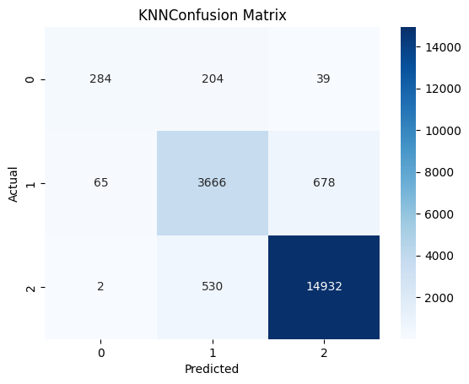
- 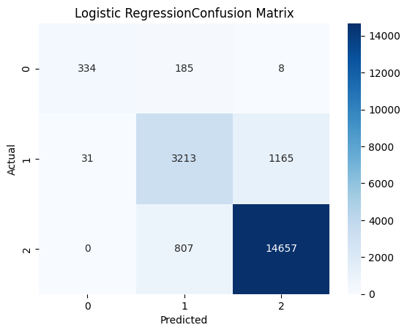
- 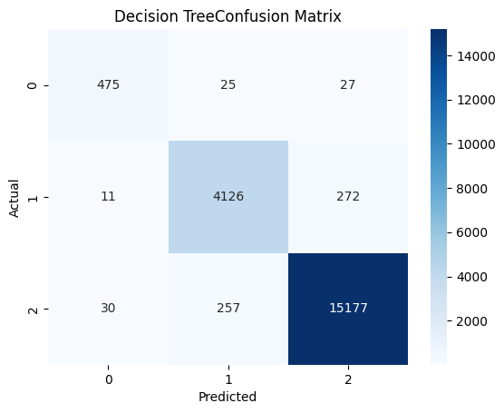
- 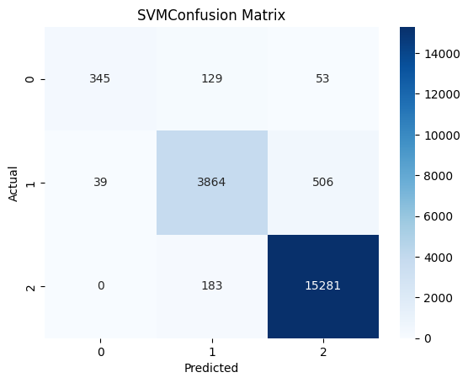

- 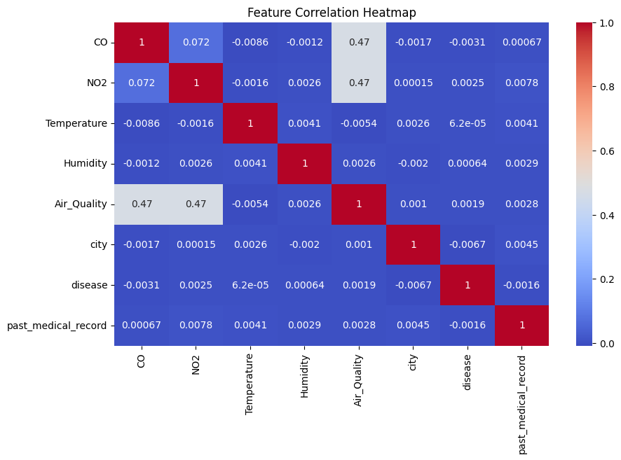
- 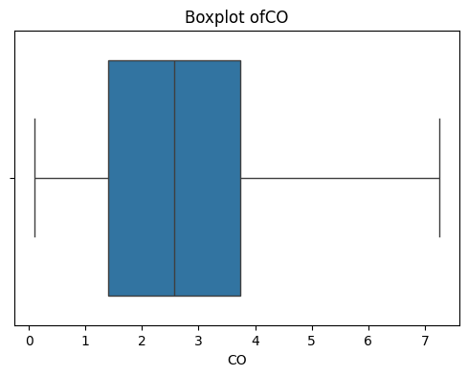

- 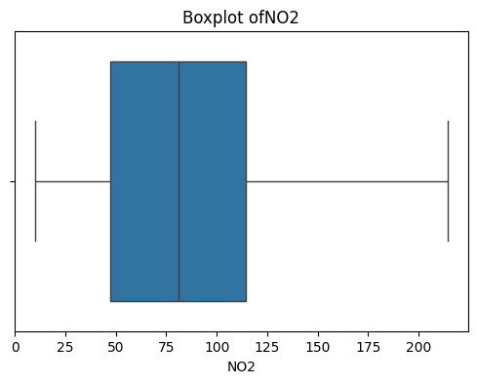
- 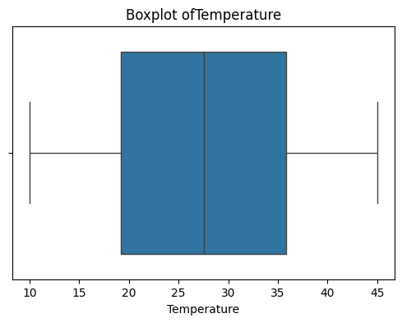
- 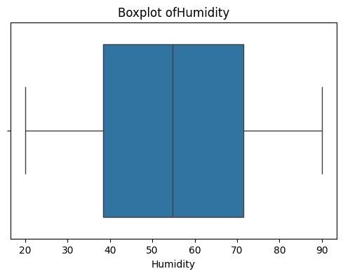
- 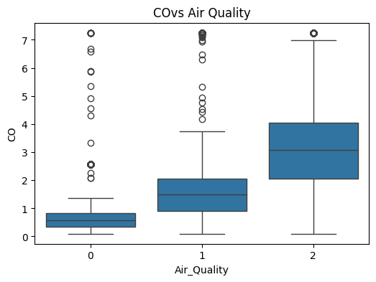
- 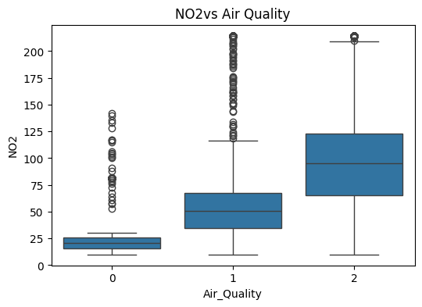
- 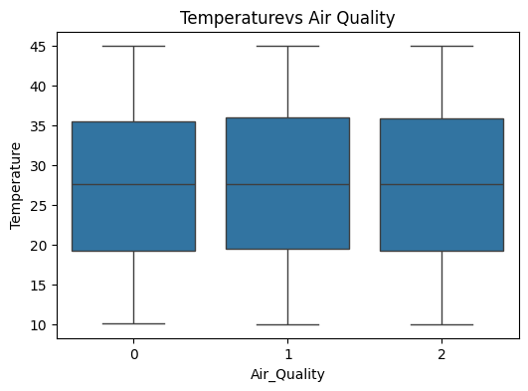
- 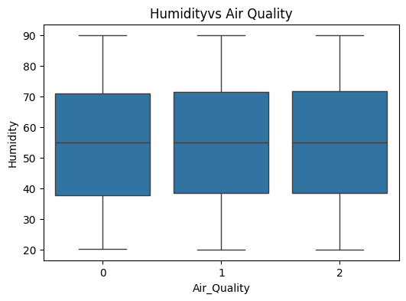
- 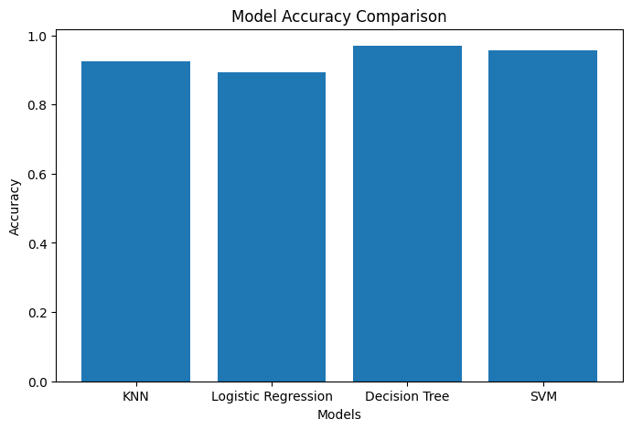
- 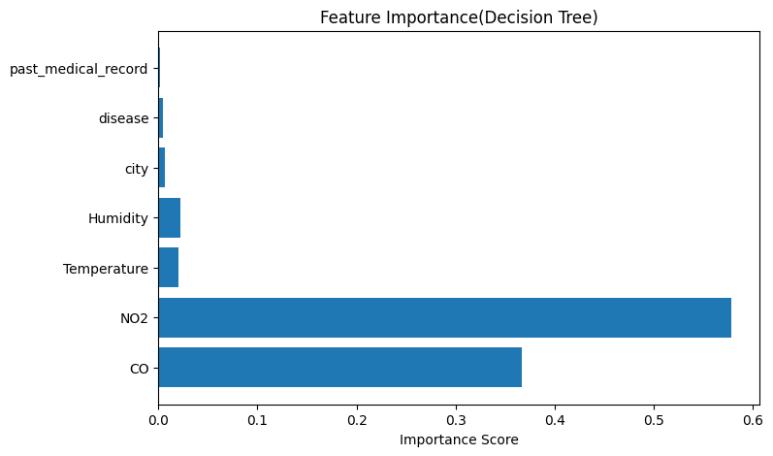
- 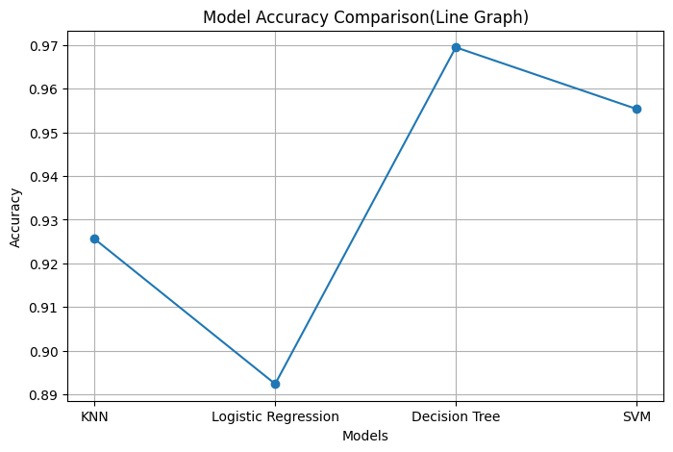
- 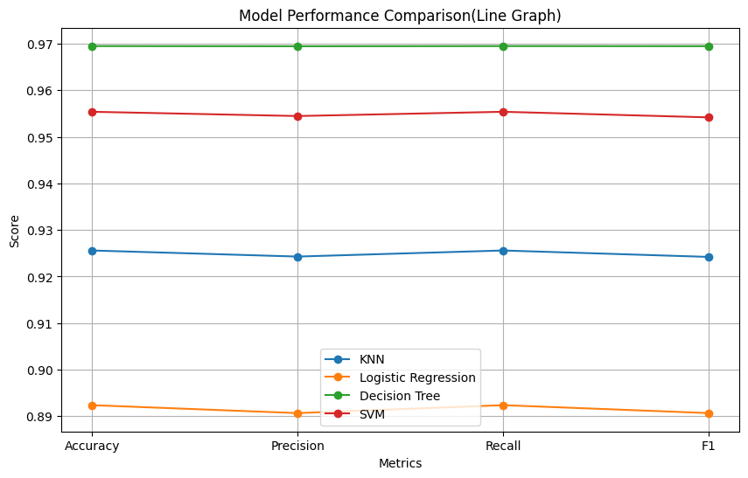
- 
- 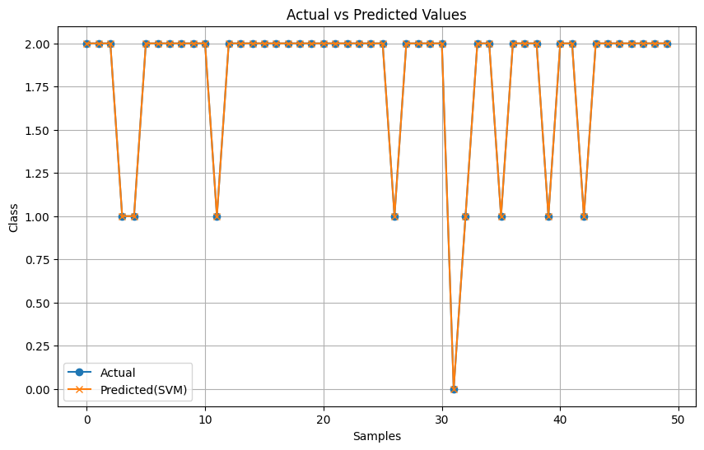
- 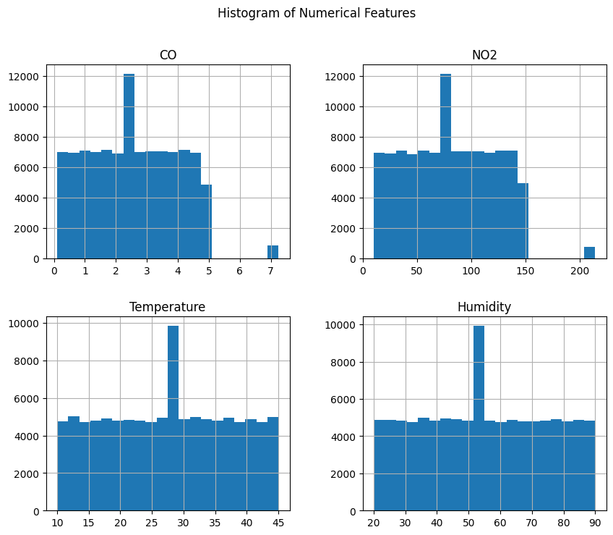

- 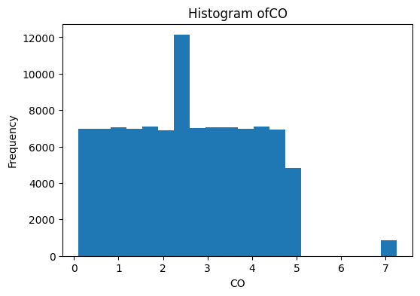
- 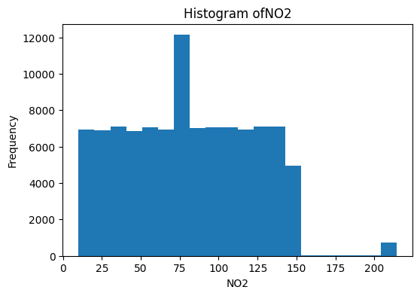
- 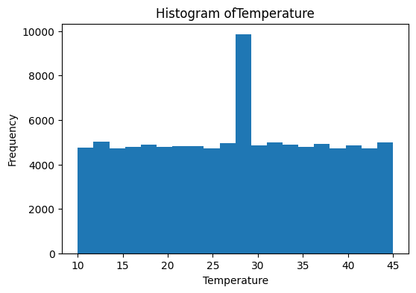
- 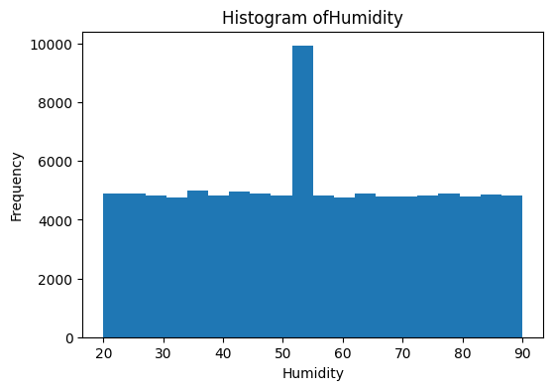
- 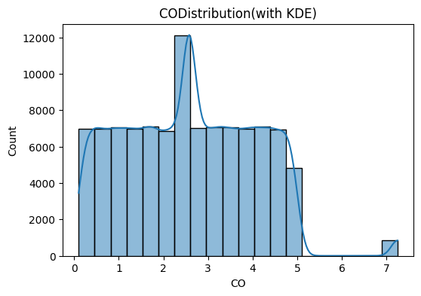
- 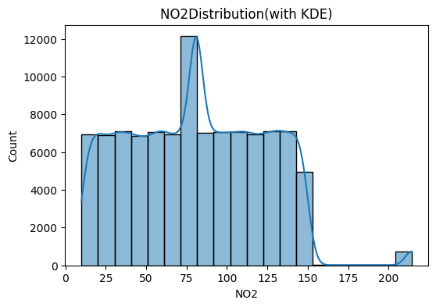
- 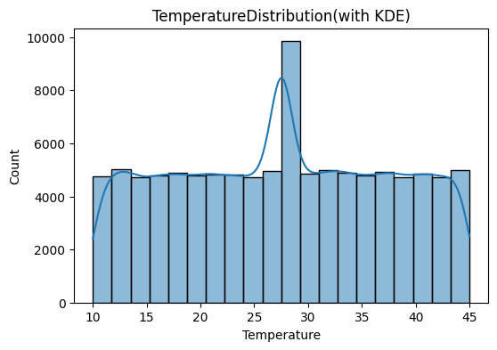
- 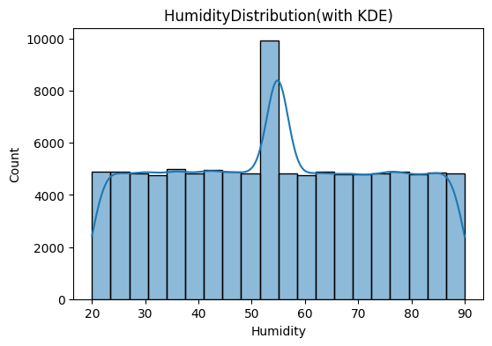
- 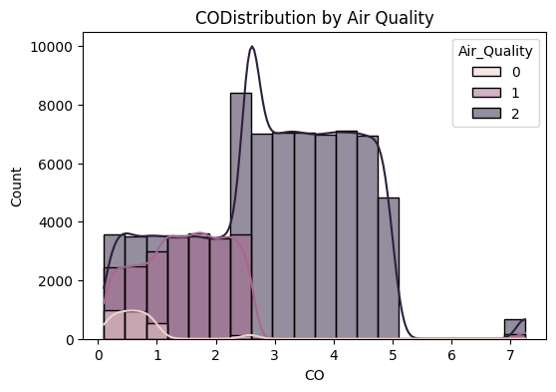
- 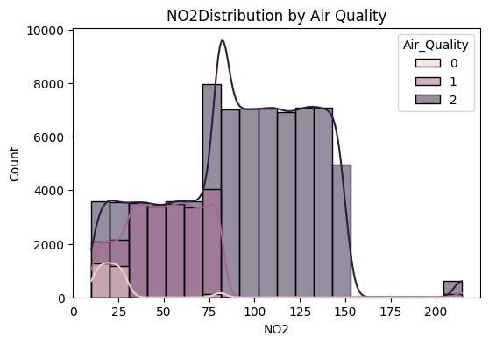
- 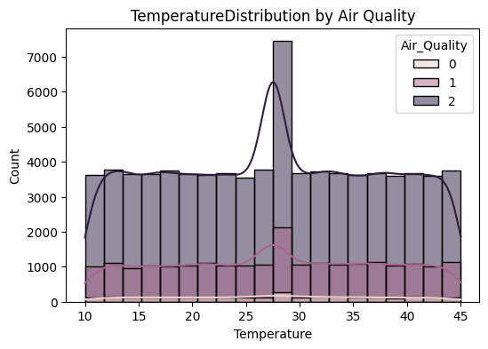
- 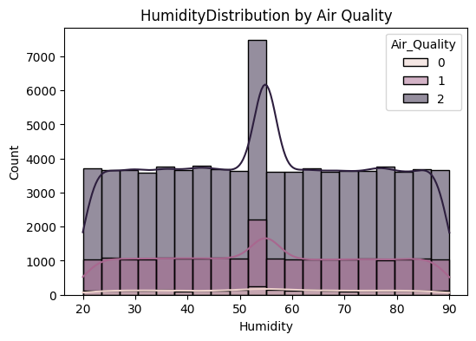
- 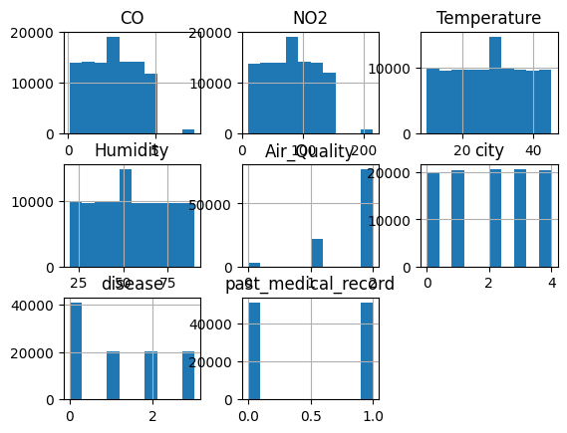

6. Conclusion and Future Scope
Conclusion
The Movie Recommendation System was successfully developed using machine learning techniques to predict whether a user would like a movie based on historical rating data. The system followed a structured pipeline including data preprocessing, feature engineering, model training, and evaluation.
Multiple algorithms such as Logistic Regression, KNN, SVM, and Decision Tree were implemented and compared using performance metrics like accuracy, precision, recall, and F1-score. This comparative analysis helped in identifying the most suitable model for the dataset.
Overall, the system demonstrates how data-driven approaches can enhance user experience by providing personalized recommendations efficiently and accurately.

Future Scope
The current system can be further improved and extended in several ways:
- Incorporation of Deep Learning Models
Use advanced techniques like Neural Networks or Collaborative Filtering for better accuracy.
- Real-Time Recommendation System
Integrate with live user data to provide dynamic and real-time suggestions.
- Hybrid Recommendation Approach
Combine content-based and collaborative filtering methods for improved performance.
- Use of Additional Features
Include metadata such as genres, reviews, and user demographics for richer insights.
- Scalability and Deployment
Deploy the system using cloud platforms and optimize it for handling large-scale data.
- User Interface Development
Build a web or mobile interface for better usability and interaction.
7. References:
Books:
- Let Us Python – Yashavant Kanetkar

Online Resources:
  - GeeksforGeeks – https://www.geeksforgeeks.org/
  - TutorialsPoint – https://www.tutorialspoint.com/cprogramming/index.htm
  - Stack Overflow – https://stackoverflow.com

